WEB AND MOBILE BASED TRICYCLE DRIVERS CONDUCT REPORTING SYSTEM.

A Capstone Project
presented to the Faculty of the
College of Computing and Information Sciences
State University of Northern Negros

In Partial Fulfillment
of the Requirements for the Degree
Bachelor of Science in Information Technology

By:

MONTEAGUDO, RELIA L
DE LUNA, DENNIS D. JR
GALLETO, Ma. TERESA B.
DIONG, RIZA MAE T.

2026

DISCLAIMER

This capstone project entitled “Web & Mobile-Based Tricycle Drivers Conduct Reporting System with Progressive Web Application (PWA)” is prepared solely for academic purposes in partial fulfillment of the requirements for the degree of Bachelor of Science in Information Technology (BSIT). The study aims to demonstrate the application of software engineering principles, systems analysis and design, database management, and web and mobile technologies in addressing challenges related to the reporting and management of tricycle driver conduct within Sagay City, Negros Occidental.
The proposed system is intended as a prototype developed for educational and research purposes. Although it is designed to provide an efficient and centralized platform for reporting incidents involving tricycle drivers, it is not intended for official implementation, commercial use, or deployment within the Philippine National Police (PNP), Tricycle Operators and Drivers Associations (TODAs), or any other organization without further evaluation, testing, enhancement, and formal authorization from the appropriate authorities.
The authors affirm that all information, concepts, data, and references used in this study were obtained from credible sources and have been properly acknowledged through appropriate citations in accordance with academic standards. Any resemblance to existing systems, organizations, or software, whether intentional or unintentional, is purely coincidental unless otherwise stated. Furthermore, the views, analyses, conclusions, and recommendations presented in this study are solely those of the authors and do not necessarily reflect the official policies or positions of the State University of Northern Negros (SUNN), the Philippine National Police (PNP), the Tricycle Operators and Drivers Associations (TODAs), or any affiliated institution. The university, research advisers, panel members, and affiliated organizations shall not be held liable for any misuse, misinterpretation, unauthorized reproduction, or commercial application of this study or the developed system.
Declaration on the Use of AI Tools
The authors acknowledge the responsible use of Artificial Intelligence (AI) tools, including large language models (LLMs), grammar and writing assistants, and other productivity applications, during the preparation of this research manuscript. These tools were utilized solely to assist in tasks such as improving grammar, sentence structure, writing clarity, document formatting, brainstorming ideas, organizing content, and generating preliminary drafts of selected sections, including the background of the study and supporting literature.
All AI-generated content was carefully reviewed, verified, edited, and validated by the researchers to ensure its accuracy, relevance, originality, and compliance with the academic policies and research standards of the State University of Northern Negros (SUNN). The authors exercised independent judgment throughout the research process and accept full responsibility for the authenticity, integrity, accuracy, and originality of the final manuscript, including all analyses, interpretations, conclusions, and recommendations presented in this study.

NAME OF PROJECT MANAGER
DIONG, RIZA MAE T

TABLE OF CONTENTS
INTRODUCTION 8
Background of the Study 8
Objectives of the Study 11
General Objective 11
Specific Objectives 12
Scope and Limitations 12
Scope of the Study 12
Limitations of the Study 13
Significance of the Study 14
SUNN Students 14
Tricycle Drivers 14
TODA Officers of Barangay Old Sagay 14
State University of Northern Negros 15
The Researchers 15
Future Researchers 15
Community of Barangay Old Sagay 15
Definition of Terms 16
Administrator 16
Attachment 16
Complaint 16
Driver Conduct 16
Notification 16
Progressive Web Application 16
Report 17
SUNN Student 17
Tricycle Operators and Drivers Association 17
User 17
Violation 17
REVIEW OF RELATED LITERATURE AND PRIOR ARTS 19
Tricycle Transportation and Driver Conduct 19
Student Complaints in Public Transportation 20
Public Complaint-Management Systems 20
Web-Mobile Complaint Service Systems 20
Evidence-Based Complaint Reporting 20
Role-Based Access and Confidentiality 21
Progressive Web Applications 21
Centralized Data Management 21
Complaint Tracking and Accountability 21
Police and Transportation-Related Complaint Systems 22
Web-Based Information Systems for Public Services 22
Mobile-Based Information Systems 22
Data Management and Centralized Records 22
Transparency, Accountability, and Report Tracking 23
Prior Arts 23
Web-Based Complaint Management Systems 23
Police Complaint Management Systems 23
Progressive Web Application Systems 24
Philippine Tricycle-Related Prior Arts 24
Synthesis and Research Gap 26
Synthesis of the Literature and Prior Arts 27
Research Framework 27
METHODOLOGY 28
Research Design 28
Software Development Methodology 28
Requirements Phase 29
Functional Requirements 30
Non-Functional Requirements 30
Planning and Feasibility 30
Technical Feasibility 31
Operational Feasibility 31
Schedule Feasibility 32
Economic Feasibility 33
Data Collection and Preparation 34
Development Phase 38
Frontend Development 38
Backend Development 39
Database Development 39
Progressive Web Application Development 39
Notification Module 39
Security Implementation 40
Testing and Evaluation 40
Functional Testing 40
Integration Testing 40
Usability Testing 40
Software Quality Evaluation 41
Evaluation Respondents 41
Evaluation Instrument 41
Functionality 41
Usability 41
Reliability 42
Efficiency 42
Security 42
User Satisfaction 42
Statistical Treatment 42
Deployment Phase 43
Maintenance and Review 43
Ethical Considerations 43
Informed Consent 43
Privacy and Confidentiality 43
Data Minimization 44
Anonymity 44
Protection of Incident Information 44
Authorized Access 44
Responsible Use of Reports 44
Law-Enforcement Coordination 44
Data Security 45
Academic Integrity and Responsible Use of Artificial Intelligence 45
REFERENCES 46

LIST OF FIGURES
Fig. 1. Conceptual Framework .............................................................................................................. 17

Fig. 2. Agile Software Development Life Cycle Model ………........................................................... 29

Fig. 3. Gantt Chart ................................................................................................................................ 31

Fig. 4. Time Adjusted Payback Period ..................................................................................................33

Fig. 5. Data Flow Diagram ................................................................................................................... 34

Fig. 6. Entity-Relationship Diagram ..................................................................................................... 36

Fig. 7. Use Case Diagram ..................................................................................................................... 37

Fig. 8. System Architecture .................................................................................................................. 38

LIST OF TABLES

Table 1. Gap Analysis .......................................................................................................................... 25

Table 2. Cost-Benefit Analysis …………............................................................................................ 32

Table 3. Five-Point Likert Scale and Interpretation ............................................................................. 41

CHAPTER I

INTRODUCTION

Background of the Study
Information and communication technology has become an important tool for improving the delivery of services in schools, communities, and organizations. Digital systems allow information to be collected, stored, retrieved, and monitored more efficiently than traditional paper-based methods. They also provide users with more convenient ways to communicate concerns and allow authorized personnel to respond to complaints in a more organized manner.
For students, accessible and reliable transportation is essential. Students need transportation when traveling to and from school, attending academic activities, completing requirements, and participating in other university-related responsibilities. At the State University of Northern Negros (SUNN), some students rely on tricycles as a practical and affordable means of transportation, particularly when traveling between the university and nearby communities.
One of the transportation groups serving the area is the Tricycle Operators and Drivers Association (TODA) located in Barangay Old Sagay, Sagay City, Negros Occidental. The TODA provides transportation services to residents and students within and around the barangay. Because students regularly interact with tricycle drivers, they may experience concerns related to driver conduct, including overcharging, reckless driving, refusal to transport passengers, discourteous behavior, unsafe driving, or other actions that may affect their safety and satisfaction.
Although these concerns may occur, students may not always report them. Some students may be unsure where to file a complaint, while others may avoid reporting because of the time and effort required to personally approach a concerned office or TODA officer. In some situations, complaints may only be communicated verbally or informally, which can result in incomplete documentation and difficulty in monitoring the progress of the concern.
The use of manual complaint procedures may also create challenges for the TODA. Complaints recorded through handwritten notes, informal conversations, or scattered files may be difficult to retrieve and organize. It may also be challenging to determine whether a particular driver has received previous complaints or whether a complaint has already been reviewed and resolved. Without a centralized record, the TODA may have limited information for monitoring driver conduct and addressing recurring concerns.
Studies on digital complaint-management systems have shown that web-based platforms can help organize the submission, documentation, tracking, and management of complaints. Such systems may provide features for user registration, complaint classification, evidence submission, status monitoring, notifications, and administrative review (Mutiawani, Hafist, & Dawood, 2024; Padiku, Takdir, & Paneo, 2024). These features can be adapted to address the specific transportation concerns experienced by students of SUNN.
A Progressive Web Application (PWA) can make the proposed system more accessible to students. Since students commonly use smartphones and other internet-connected devices, a PWA can allow them to access the system through a web browser without requiring them to download a separate application from an app store. A responsive interface can also allow the system to be used on mobile phones, tablets, and desktop computers.
The proposed system will not serve as a general complaint platform for all residents of Sagay City. Its focus will be limited to complaints submitted by students of the State University of Northern Negros concerning the conduct of tricycle drivers affiliated with the TODA of Barangay Old Sagay. The system will also be used by authorized TODA officers and designated administrators who are responsible for reviewing and managing the complaints.
The system will not automatically determine whether a tricycle driver is guilty of a violation. Instead, it will serve as a reporting, documentation, and monitoring platform. Complaints submitted through the system must still undergo appropriate review and verification by authorized TODA officers or other responsible personnel. Any disciplinary action or final decision will remain under the authority of the concerned organization and applicable rules and regulations.
In response to this concern, the researchers propose the development of a Web and Mobile-Based Tricycle Drivers Conduct Reporting System with Progressive Web Application (PWA) for the TODA of Barangay Old Sagay, Sagay City, Negros Occidental. The proposed system will provide SUNN students with a convenient and structured way to submit complaints regarding tricycle driver conduct. It will also help authorized TODA officers organize reports, review complaints, monitor their status, maintain driver records, and document actions taken.
Through this system, the researchers aim to improve communication between SUNN students and the TODA of Barangay Old Sagay. The system may also encourage students to report legitimate transportation concerns and assist the TODA in handling complaints in a more transparent, organized, and accountable manner.

Objectives of the Study

General Objective
The general objective of this study is to design and develop a Web and Mobile-Based Tricycle Drivers Conduct Reporting System with Progressive Web Application (PWA) for the TODA of Barangay Old Sagay, Sagay City, Negros Occidental. The system will provide students of the State University of Northern Negros with an accessible platform for submitting complaints regarding tricycle driver conduct and assist authorized TODA officers in receiving, reviewing, documenting, monitoring, and managing student-submitted complaints.

Specific Objectives
- Examine the existing process used by the TODA of Barangay Old Sagay in receiving and managing complaints involving tricycle driver conduct.
- Identify the problems experienced by SUNN students when reporting concerns about tricycle drivers.
- Determine the functional and non-functional requirements needed for the proposed complaint-reporting system.
- Design and develop a web and mobile-based system that allows SUNN students to submit complaints involving tricycle drivers affiliated with the selected TODA.
- Provide a structured complaint form for incident details and permitted supporting evidence.
- Develop a centralized database for student users, driver profiles, complaints, attachments, notifications, and complaint-status history.
- Provide authorized TODA officers with features for reviewing, verifying, updating, monitoring, and managing complaints.
- Implement notifications that inform students about the receipt and status of their complaints.
- Evaluate the system based on functionality, usability, reliability, efficiency, security, compatibility, and user satisfaction.

Scope and Limitations

Scope of the Study
This study focuses on the design and development of a Web and Mobile-Based Tricycle Drivers Conduct Reporting System with Progressive Web Application for the TODA of Barangay Old Sagay, Sagay City, Negros Occidental. The primary complainants will be students of the State University of Northern Negros, and the covered complaints will involve tricycle drivers affiliated with the selected TODA.
The proposed system will include the following features:
• Student registration and account authentication.
• Student profile management.
• Management of authorized accounts and tricycle driver profiles.
• Complaint submission, categorization, and incident details.
• Permitted digital attachment submission.
• Complaint review, verification, status updates, and action records.
• Notifications, complaint history, search, filtering, and administrative reports.
• Responsive access through desktop and mobile devices with selected PWA features.
The system will involve SUNN students, authorized TODA officers, system administrators, and tricycle drivers with authorized access.

Limitations of the Study
- The system will focus only on the TODA operating in Barangay Old Sagay and will not cover all TODAs in Sagay City.
- The primary complainants will be SUNN students; complaints from the general public are outside the primary scope.
- Only drivers affiliated with the selected TODA will be covered.
- The system will manage transportation-related conduct complaints but will not determine guilt or legal validity.
- Investigation, verification, disciplinary action, and final decisions will remain with authorized personnel.
- The authenticity and sufficiency of uploaded evidence will depend on the information supplied by the complainant.
- Internet access will generally be required for authentication, submission, synchronization, and notifications.
- The project will produce a responsive web application with PWA capabilities, not separate native Android or iOS applications.
- The system is an academic prototype and will require further approval and testing before official adoption.

Significance of the Study

SUNN Students
The system will provide students with an accessible and organized way to report concerns involving tricycle drivers. Students may submit complaints, include relevant details, and monitor updates without relying solely on verbal communication or personally visiting the TODA office.

Tricycle Drivers
The system may encourage professional and safe conduct. Because complaints will be reviewed through a structured process, drivers may also benefit from fairer documentation and evaluation. A complaint will not automatically be treated as proof of guilt.

TODA Officers of Barangay Old Sagay
The system will help officers receive complaints, review incident details, monitor status, maintain driver records, record actions, identify recurring concerns, and prepare reports for decision-making.

State University of Northern Negros
The university may benefit from a technology-based mechanism that supports the reporting of transportation concerns affecting its students. The project also demonstrates how Information Technology can address a practical student and community issue.

The Researchers
The study will strengthen the researchers’ skills in software development, database management, PWA implementation, systems analysis, testing, security, and research documentation.

Future Researchers
The study may serve as a reference for future transportation, student-support, complaint-reporting, and community information systems

Community of Barangay Old Sagay
The community may benefit from a more organized process for addressing tricycle-related concerns and promoting communication and accountability.

Definition of Terms

Administrator
An authorized individual who manages users, records, settings, and system functions. In this study, the administrator manages accounts, driver information, complaints, notifications, and access permissions.

Attachment
A digital file submitted with a complaint. In this study, it may be a photograph or other permitted file uploaded by a SUNN student as supporting evidence.

Complaint
An expression of concern regarding an experience or behavior that requires review. In this study, it is a report submitted by a SUNN student about a driver affiliated with the TODA of Barangay Old Sagay

Driver Conduct
The behavior and actions of a driver while operating a tricycle and interacting with passengers.

Notification
A system-generated message informing a user about a complaint-related update or activity

Progressive Web Application
A web application with selected mobile-application features. In this study, it allows SUNN students and authorized TODA officers to access the system through modern browsers.

Report
A documented record of an incident or complaint submitted for review.

SUNN Student
A currently enrolled student of the State University of Northern Negros who may use the system to submit a complaint

Tricycle Operators and Drivers Association
An organization of tricycle operators and drivers. In this study, it specifically refers to the TODA operating in Barangay Old Sagay.

User
An individual authorized to access and use the system.

Violation
An act that fails to comply with an established rule or regulation. In this study, it refers to a confirmed offense recorded after appropriate review.

Conceptual Framework
The study uses the Input–Process–Output–Outcome framework. The inputs include the transportation concerns of SUNN students, the existing complaint process of the TODA of Barangay Old Sagay, user requirements, driver information, incident details, and available technical resources.
INPUT
- Existing complaint reporting process in Sagay City
- Functional requirements
- Non-functional requirements
- Commuter information
- Tricycle driver records
- Complaint details
- Supporting digital evidence (photos/files)
- Policies and procedures of the PNP and TODA
PROCESS
1. Requirements Analysis
2. System Planning
3. Database Design
4. User Interface Design
5. System Development using PWA Technology
6. Complaint Submission
7. Complaint Verification and Monitoring
8. Violation Recording
9. Report Generation
10. System Testing
11. System Evaluation
OUTPUT
- Web and Mobile-Based Tricycle Drivers Conduct
- Reporting System with Progressive Web Application (PWA) for Sagay City
OUTCOME
- Faster complaint reporting
- Improved complaint monitoring
- Centralized complaint records
- Increased transparency and accountability
- Better decision-making by PNP and TODA
- Improved public transportation services
- Enhanced commuter satisfaction in Sagay City

Fig. 1. Conceptual Framework
The process includes requirements gathering, analysis, planning, system design, development, testing, evaluation, revision, and deployment preparation. The output will be a Web and Mobile-Based Tricycle Drivers Conduct Reporting System with PWA for the selected TODA and its SUNN student complainants.
The expected outcome is a more convenient, organized, and transparent process for submitting and managing student complaints. The system is expected to support improved documentation, status monitoring, communication, and accountability while leaving investigation and disciplinary decisions to authorized personnel.

CHAPTER II

REVIEW OF RELATED LITERATURE AND PRIOR ARTS

Tricycle Transportation and Driver Conduct
Tricycles are an important form of local transportation in many Philippine communities. They provide short-distance transportation to residents, workers, and students traveling between homes, schools, markets, and other establishments. For SUNN students, tricycles may be a convenient and affordable option when traveling to and from the university.
Studies on tricycle transportation emphasize safety, reliability, affordability, comfort, and proper regulation. Cueto, Uy, and Diaz (2021) examined electric tricycles in General Santos City and identified safety and transportation regulation as important concerns. Their findings support the need to monitor driver conduct and provide an appropriate channel for reporting transportation-related problems. This study applies those concerns to SUNN students using tricycle services affiliated with the TODA of Barangay Old Sagay.

Student Complaints in Public Transportation
Students may experience concerns such as unsafe driving, overcharging, refusal to transport passengers, or discourteous treatment. However, they may hesitate to report these concerns when the process is unclear or inconvenient. A structured digital platform can guide students in submitting incident details and supporting evidence while giving authorized personnel a clear way to manage the report. The proposed system is therefore designed specifically for SUNN students rather than for the general public

Public Complaint-Management Systems
Complaint-management systems organize the submission, review, monitoring, and processing of complaints. Mutiawani, Hafist, and Dawood (2024) developed a web-based complaints-management system that addressed inefficiencies in manual complaint handling through structured workflows and multiple user roles. The proposed system adopts these concepts but applies them to student complaints about tricycle driver conduct and TODA-based review.

Web-Mobile Complaint Service Systems
Padiku, Takdir, and Paneo (2024) examined a web-mobile complaint service system intended to improve complaint handling and resource management. Their work supports the use of web and mobile access for users and administrators. The proposed system applies this approach to SUNN students and includes driver profiles, transportation complaint categories, evidence attachments, status tracking, and notifications.

Evidence-Based Complaint Reporting
A complaint is more useful when it contains the date, time, location, description, driver or vehicle information, and supporting evidence when available. The proposed system will permit SUNN students to submit appropriate digital attachments. These files will be protected through access controls and will not automatically be treated as proof of a violation. Review and verification will remain the responsibility of authorized TODA personnel.

Role-Based Access and Confidentiality
Different users require different access privileges. Students should be able to submit and monitor their own complaints, while TODA officers need access to complaints relevant to their duties. Role-based access can help protect student identities, driver information, and sensitive attachments. The proposed system will apply role-based access to restrict functions and records according to each user’s responsibility

Progressive Web Applications
Patil and Shah (2022) and Jhala (2021) discussed PWAs as cross-platform alternatives to native mobile applications. PWAs can provide responsive interfaces, installation support, caching, and selected offline features. This technology is suitable for the proposed system because SUNN students may use different devices to submit complaints. Features that require current database access, such as authentication and synchronization, will still require an internet connection.

Centralized Data Management
A centralized database can connect student accounts, driver profiles, complaints, attachments, statuses, notifications, and actions taken. This allows authorized TODA officers to retrieve related information more efficiently and review complaint histories when appropriate. The proposed system will use centralized records to improve organization and monitoring.

Complaint Tracking and Accountability
Complaint tracking allows students and authorized personnel to determine the current stage of a report. Statuses may include Submitted, Received, Under Review, Verified, Referred, Resolved, and Closed. Tracking can improve communication and create a clearer history of actions, although it does not guarantee a particular outcome or replace official decision-making.

Police and Transportation-Related Complaint Systems
Gunasundari et al. (2023) proposed a web-based police complaint-management system with electronic filing, tracking, assignment, and monitoring. This is relevant to the proposed study because some transportation concerns may involve public safety. However, the proposed system is primarily intended for the TODA of Barangay Old Sagay and will not replace police investigation or legal procedures.

Web-Based Information Systems for Public Services
Web-based systems make public services more accessible by allowing users to submit and manage information through internet-connected devices. They can centralize records, reduce manual work, and improve efficiency. The proposed system applies these principles by digitally managing tricycle reports, driver information, violations, attachments, and notifications.

Mobile-Based Information Systems
Mobile-based systems allow users to access services and submit reports using smartphones or other mobile devices. This is useful for transportation incidents because users can report incidents closer to when and where they occur. The proposed system uses a responsive web design so it can be accessed through both desktop and mobile devices.

Data Management and Centralized Records
Centralized data management allows reports and related information to be stored, organized, and retrieved efficiently. The proposed system uses interconnected records for users, drivers, reports, violations, attachments, and notifications. This helps authorized personnel review driver histories, previous reports, violations, and complaint progress in one system.

Transparency, Accountability, and Report Tracking
Complaint tracking improves transparency by allowing users and authorized personnel to monitor the progress of submitted reports. Statuses such as Submitted, Under Review, Verified, Referred, Resolved, and Closed can show the current stage of a complaint. In the proposed system, this feature helps commuters know whether their reports have been received and processed.

Prior Arts

Web-Based Complaint Management Systems
Web-based complaint management systems provide centralized platforms for receiving and processing complaints.
Mutiawani et al. (2024) developed a web-based complaint management system using Flask and Google Cloud services. The system supported four user groups with different responsibilities and access privileges. Black-box and white-box testing were performed, and usability was evaluated using the USE Questionnaire.
The system demonstrates the importance of role-based access, complaint tracking, and structured workflows. These concepts are relevant to the proposed tricycle reporting system, which similarly requires different permissions for commuters and authorized personnel.
However, the system was designed for a university laboratory environment rather than public transportation. The proposed study adapts the complaint-management concept to tricycle driver conduct and transportation-related incidents.

Police Complaint Management Systems
Web-based police complaint systems demonstrate how online reporting can be applied to law-enforcement-related processes.
Gunasundari et al. (2023) proposed a web-based police complaint management system that allowed users to file complaints electronically and provided mechanisms for tracking, assigning, and monitoring complaints.
This prior art is relevant to the proposed system because reports involving driver misconduct may include incidents with potential public-safety or law-enforcement implications.
However, a general police complaint system does not specifically address tricycle transportation. The proposed system focuses on driver conduct reporting, allowing transportation-specific information such as driver identification, vehicle information, incident category, location, and supporting evidence to be recorded systematically.

Progressive Web Application Systems
PWA-based systems have been investigated as alternatives to conventional native mobile applications. Patil and Shah (2022) compared PWA architecture with native, mobile web, and hybrid approaches and highlighted features such as offline operation and background synchronization.

Jhala (2021) likewise emphasized the ability of PWAs to provide native-like experiences through web technologies while maintaining cross-platform accessibility.
These characteristics make PWA technology suitable for the proposed tricycle reporting system because the intended users may access the application through different devices and operating systems.

Philippine Tricycle-Related Prior Arts
Philippine studies have also examined tricycle transportation from transportation-management and safety perspectives.
Cueto et al. (2021) investigated electric tricycles in General Santos City and examined transportation factors including safety, reliability, comfort, affordability, and infrastructure. Their research identified hazards associated with motorized tricycle operations and proposed recommendations involving traffic management, franchise regulation, and transportation planning.
Another Philippine study conducted in Tayabas City examined the compliance of tricycle drivers with traffic rules and regulations. The researchers used a quantitative descriptive design and surveyed selected enforcers and police officers. The study sought to determine compliance levels and identify problems related to tricycle drivers' observance of traffic regulations.
These studies establish the importance of tricycle driver behavior, traffic-rule compliance, and transportation safety. However, they primarily investigate the transportation problem rather than developing a digital reporting and monitoring platform.
This distinction creates an opportunity for the proposed Web and Mobile-Based Tricycle Drivers Conduct Reporting System to combine transportation-related concerns with information technology.

Table 1. Gap Analysis
Related System / Study | Web-Based |  | Mobile  Accessible |  | Complaint  Reporting |  | Evidence Upload |  | Status Tracking |  | Driver Records | Transportation Focus | PWA
Web-Based Faculty Complaint Management System | ✓ |  | ✗ |  | ✓ |  | — |  | ✓ |  | ✗ | ✗ | ✗
Syiah Kuala University Complaint Management System | ✓ |  | ✓ |  | ✓ |  | ✓ |  | ✓ |  | ✗ | ✗ | ✗
Web-Mobile Complaint Service System | ✓ |  | ✓ |  | ✓ |  | — |  | ✓ |  | ✗ | ✗ | ✗
Web-Based Police Complaint Management System | ✓ |  | ✓ |  | ✓ |  | — |  | ✓ | ✗ |  | ✗ | ✗
Tricycle Transportation Studies | ✗ | ✗ |  | ✗ |  | ✗ |  | ✗ |  | ✓ |  | ✓ | ✗
PWA Research / Prior Arts | ✓ | ✓ |  | — |  | — |  | — |  | — |  | — | ✓
Proposed System | ✓ | ✓ |  | ✓ |  | ✓ |  | ✓ |  | ✓ |  | ✓ | ✓

Synthesis and Research Gap
The reviewed literature shows that tricycles are important to local mobility, driver conduct affects passenger safety and satisfaction, and digital complaint systems can improve documentation and monitoring. Web-mobile systems improve access, while PWAs support cross-platform use.
Existing systems, however, are generally designed for laboratories, offices, general public services, or police complaints. Tricycle studies often focus on safety and compliance rather than developing a student-centered reporting system. The gap addressed by this study is the absence of a dedicated platform where SUNN students can submit complaints involving drivers affiliated with the TODA of Barangay Old Sagay, with features for evidence, tracking, notifications, driver records, and TODA-based management.

Synthesis of the Literature and Prior Arts
The reviewed studies show the importance of tricycle safety, driver compliance, digital complaint management, and online incident reporting. PWA research further supports the use of cross-platform web technology. These concepts are combined in the proposed system to provide commuter reporting, driver identification, evidence submission, violation management, notifications, tracking, and administrative monitoring in one platform.

Research Framework
The research framework connects student transportation concerns, digital complaint management, and PWA technology. SUNN students’ experiences provide the basis for identifying system requirements. Complaint-management principles guide the reporting, review, tracking, notification, and record-management features. PWA technology provides access through mobile and desktop browsers. The framework follows this progression: student transportation concerns → reporting requirements → system design → web and mobile PWA development → TODA complaint management → improved monitoring and accountability.

CHAPTER III

METHODOLOGY

Research Design
This study will use a developmental research design supported by a descriptive approach. The developmental design is appropriate because the purpose is to design, develop, test, and evaluate a software system for SUNN students and the TODA of Barangay Old Sagay. The descriptive approach will be used to describe the current complaint process and the needs of the intended users. The study will not determine the legal guilt of any driver; it will develop a tool for reporting, documenting, monitoring, and managing complaints.

Software Development Methodology
The researchers will use the Agile Software Development Life Cycle. Agile is appropriate because the system can be developed in modules and improved through feedback from SUNN students and authorized TODA officers. The major activities will include requirements gathering, planning, design, development, testing, deployment preparation, and maintenance. Revisions may be made when testing or stakeholder feedback identifies a need for improvement.
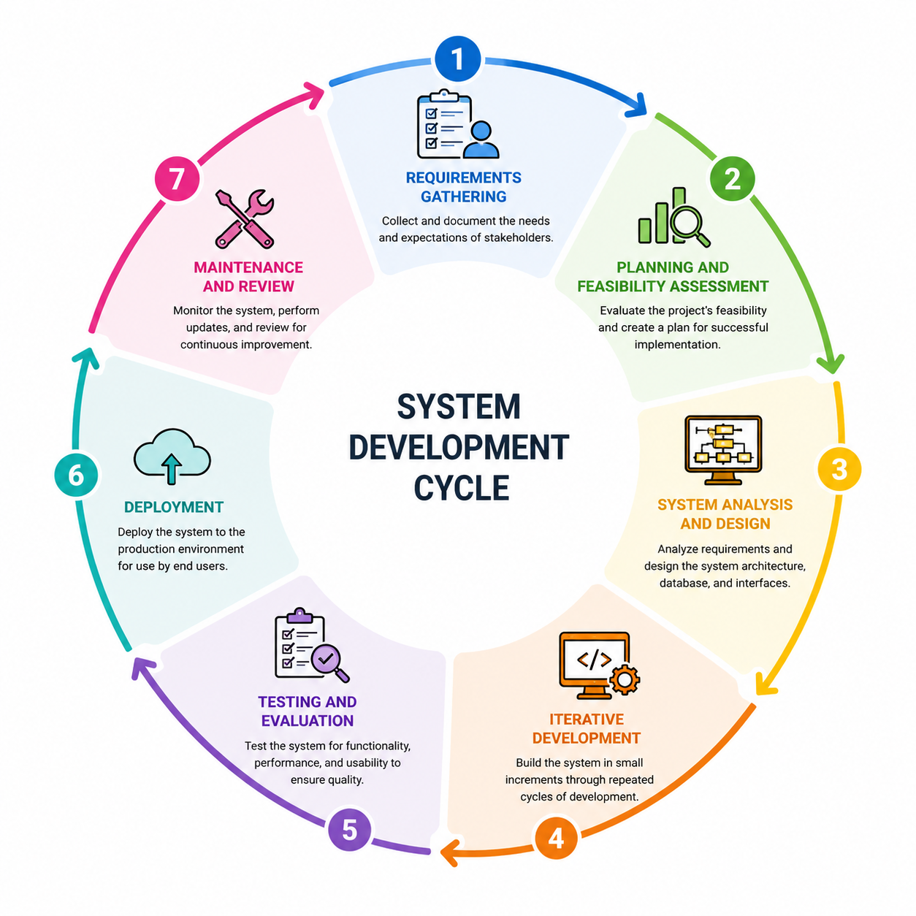
Fig. 2. Agile Software Development Life Cycle Model
The development process followed several key phases:

Requirements Phase
The requirements phase will identify the needs of SUNN students, authorized TODA officers, selected tricycle drivers, and administrators. The researchers will examine how complaints are currently received, recorded, reviewed, and resolved. They will identify problems involving accessibility, documentation, evidence, communication, status monitoring, and record retrieval.

Functional Requirements
The system will provide student registration and authentication, profile management, driver-profile management, complaint submission, incident details, complaint categorization, attachment submission, review and verification, status updates, action records, confirmed-violation records, notifications, complaint history, search and filtering, administrative dashboards, reports, and role-based access control.

Non-Functional Requirements
The system should be usable, functional, reliable, efficient, secure, compatible, maintainable, accessible, and privacy-conscious. It should be understandable to SUNN students, allow authorized TODA officers to manage reports, protect sensitive information, and operate on commonly used modern browsers and devices.

Planning and Feasibility
The researchers will assess whether the project can be completed using the available time, skills, equipment, software, network connection, and financial resources. The assessment will cover technical, economic, operational, and schedule
feasibility.
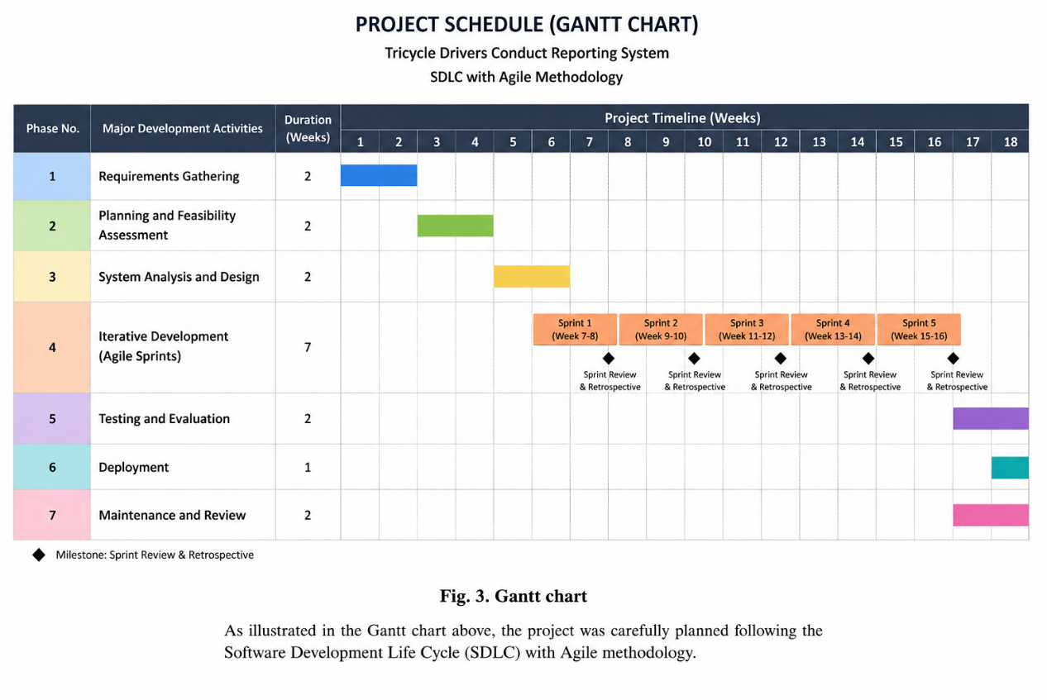Fig. 3. Gantt chart

Technical Feasibility
Technical feasibility will consider development computers, internet connectivity, mobile testing devices, web browsers, hosting, databases, programming frameworks, PWA technologies, file storage, and security tools. The system will be developed as a web application accessible through mobile and desktop devices.

Operational Feasibility
Operational feasibility will assess whether the system can support the actual needs of SUNN students and TODA officers. The assessment will consider complaint-submission convenience, ease of review, status monitoring, driver-record retrieval, evidence management, notifications, user acceptance, and compatibility with current TODA procedures. The system will support existing procedures rather than automatically replace them.

Schedule Feasibility
The project will include planning, requirements gathering, system analysis, interface and database design, backend and frontend development, PWA implementation, testing, evaluation, revision, deployment preparation, and documentation. The schedule may be adjusted according to stakeholder feedback, development progress, and academic requirements.
Table 2 Cost-Benefit Analysis
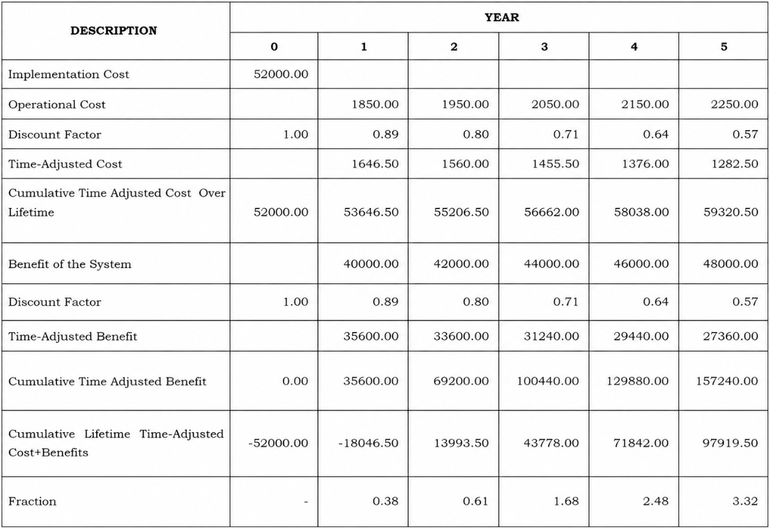

Return of Investment (%): 165.07
Net Present Value: 97919.50
Time Adjusted Payback Period 1.54 Years
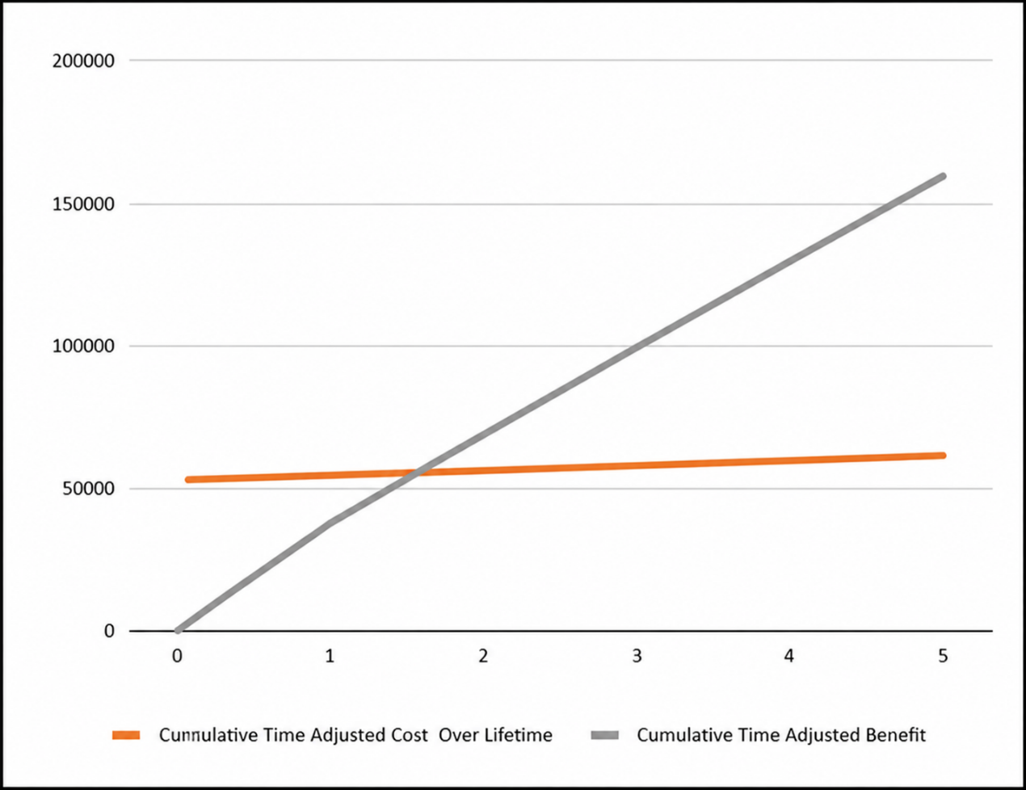
Fig. 4 Time Adjusted Payback Period

Economic Feasibility

The proposed system is economically feasible based on its estimated costs and projected benefits over five years. With an ROI of 165.07%, NPV of ₱97,919.50, and Time-Adjusted Payback Period of 1.54 years, the analysis shows that the expected benefits exceed the costs of developing and operating the system.

Data Collection and Preparation
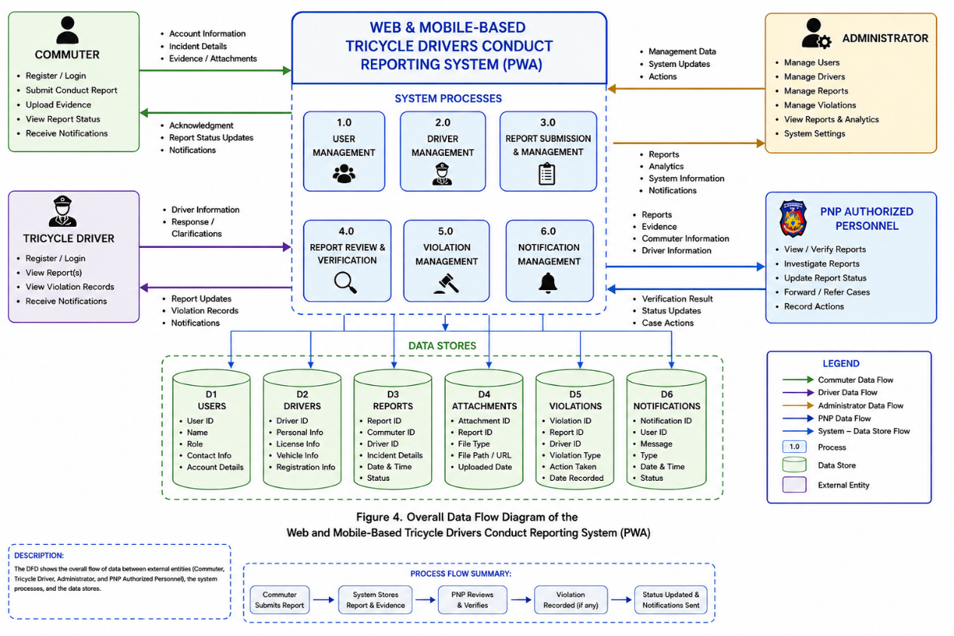
Information will be collected through interviews with authorized TODA officers, questionnaires for SUNN students, observation of existing procedures, discussions with selected drivers, and system-evaluation activities. Only information necessary for the study and system development will be collected. Relevant data may include student accounts, driver profiles, incident details, complaint categories, attachments, statuses, actions taken, notifications, and review records.

Fig. 5. Data Flow Diagram
The Data Flow Diagram (DFD) illustrates the overall flow of information within the Web and Mobile-Based Tricycle Drivers Conduct Reporting System with Progressive Web Application (PWA). The system involves four primary users: Commuters, Tricycle Drivers, Administrators, and authorized PNP personnel.
Commuters can register, submit reports regarding tricycle driver conduct, provide incident details and supporting evidence, and monitor report status. Tricycle drivers can maintain relevant driver information and receive authorized notifications. Administrators manage users, drivers, reports, violations, and system records, while authorized PNP personnel review and verify reports and update relevant statuses or records according to applicable procedures.
The system processes user management, driver management, report submission and management, report review and verification, violation management, and notification management. The information is stored in centralized data stores for users, drivers, reports, attachments, violations, and notifications. Overall, the DFD demonstrates how the proposed system centralizes and organizes the reporting, processing, storage, and monitoring of tricycle driver conduct reports while supporting accessibility
through web and PWA technologies.
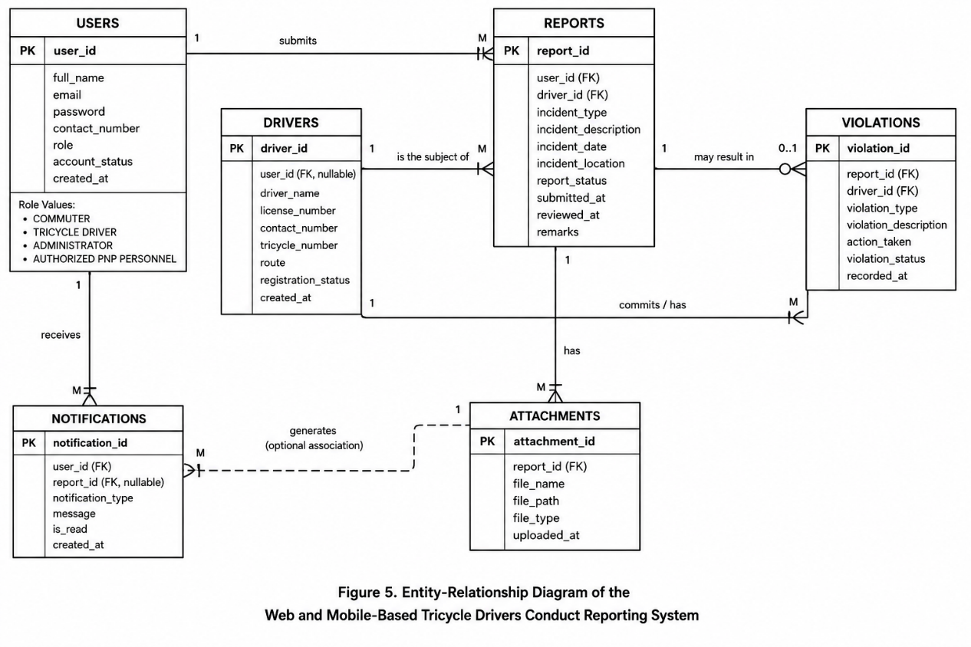
Fig. 6. Entity-Relationship Diagram
Figure 6 illustrates the Entity-Relationship Diagram (ERD) of the proposed Web and Mobile-Based Tricycle Drivers Conduct Reporting System, showing the relationships among users, drivers, reports, attachments, violations, and notifications that support the system’s reporting, monitoring, and record-management processes.
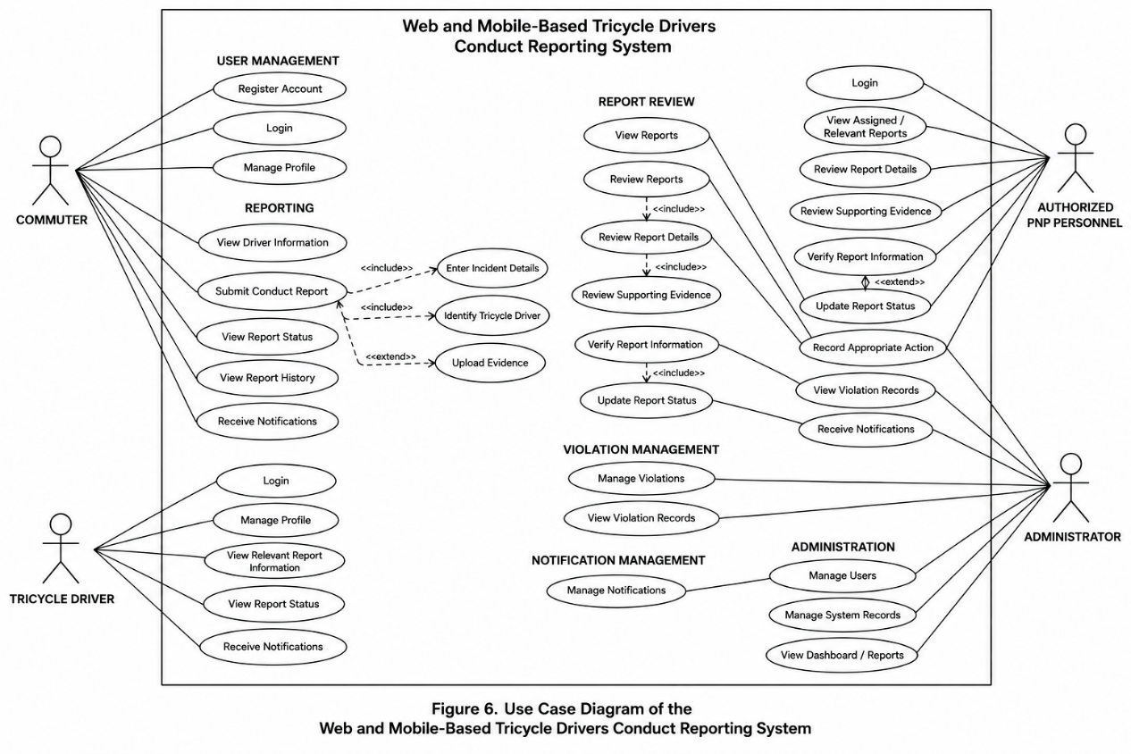
Fig. 7. Use Case Diagram
Figure 7 illustrates the Use Case Diagram of the proposed Web and Mobile-Based Tricycle Drivers Conduct Reporting System, showing the interactions and functional responsibilities of commuters, tricycle drivers, administrators, and authorized PNP personnel within the system.

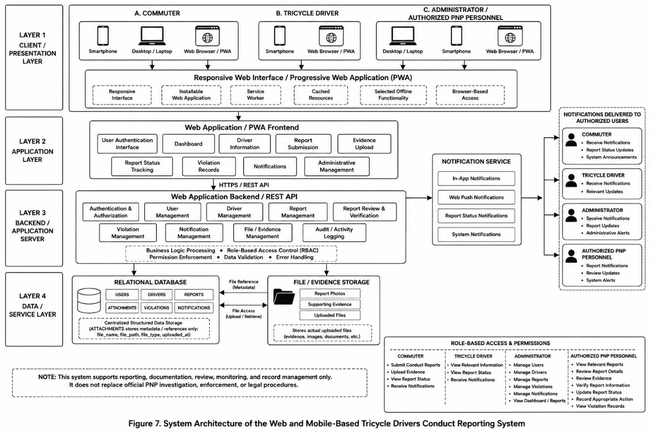
Fig. 8. System Architecture
Figure 8 illustrates the system architecture of the proposed Web and Mobile-Based Tricycle Drivers Conduct Reporting System, showing how users access the PWA through various devices and how the frontend, backend, database, evidence storage, notification services, and role-based access controls interact to support secure reporting, monitoring, and record management.

Development Phase
The development phase will convert the approved requirements and designs into a working prototype. The system will be developed incrementally, with each module tested and improved before the next module is finalized.

Frontend Development
The frontend will include student registration and login, student dashboard, complaint form, attachment upload, complaint history, status page, notifications, TODA dashboard, administrator dashboard, search, and filtering. The interface will be responsive and designed for mobile and desktop screens

Backend Development
The backend will manage authentication, authorization, student and driver records, complaint processing, attachments, notifications, status updates, search, reports, and data validation. User permissions will determine which functions and records may be accessed.

Database Development
The database will store users, students, drivers, TODA information, complaints, categories, attachments, statuses, violations, actions, notifications, and appropriate audit information. Keys, relationships, constraints, and indexes will be applied to maintain data integrity. The database will be tested for authorized insertion, retrieval, updating, and management of records.

Progressive Web Application Development
PWA features may include a web app manifest, service worker, responsive design, installation support, caching, and mobile-friendly navigation. Offline functionality will be limited to features that can safely operate without current access to the database. Authentication, complaint submission, notifications, and synchronization may require internet access.

Notification Module
The notification module may inform students and authorized TODA officers when a complaint is submitted, received, placed under review, verified, referred, acted upon, resolved, or closed. Notifications will follow each user’s role and access permissions.

Security Implementation
Security measures may include secure authentication, password hashing, role-based access control, session management, input validation, file-upload validation, restricted access to sensitive records, secure database queries, HTTPS, backups, and protection of student and driver information. Students will access their own complaints, while TODA officers will access information needed for their official responsibilities.

Testing and Evaluation
Testing will be conducted throughout development to determine whether the system works according to its requirements and is acceptable to its intended users.

Functional Testing
Functional testing will cover student registration, login, complaint submission, categorization, attachment upload, driver management, complaint review, status updates, action records, notifications, search, filtering, reports, and administrative functions.

Integration Testing
Integration testing will examine the connection between the frontend and backend, backend and database, complaint submission and notifications, student accounts and complaint history, driver records and complaints, complaints and violation records, and PWA functions and system access.

Usability Testing
Usability testing will assess registration, navigation, complaint submission, attachment upload, status checking, notifications, mobile responsiveness, information organization, and overall satisfaction. Selected SUNN students and TODA personnel will perform representative tasks and provide feedback.

Software Quality Evaluation
The system may be evaluated using selected factors from the McCall Software Quality Model, including correctness, reliability, usability, efficiency, integrity, maintainability, flexibility, testability, portability, reusability, and interoperability. The Computer System Usability Questionnaire may also be used to assess system usefulness, information quality, interface quality, and overall satisfaction. The final instrument will follow the requirements of the research adviser.

Evaluation Respondents
Respondents may include SUNN students who use tricycles affiliated with the TODA of Barangay Old Sagay, authorized TODA officers, selected tricycle drivers, and technical evaluators or administrators. SUNN students will be the primary evaluation respondents because they are the intended complainants. Participation will be voluntary and conducted with appropriate consent.

Evaluation Instrument
A structured questionnaire will evaluate functionality, usability, interface design, information quality, reliability, efficiency, security, complaint-submission convenience, report monitoring, notification usefulness, and user satisfaction. The instrument should be reviewed by the research adviser or qualified evaluators before distribution.

Functionality
Measures whether the system provides the required features and performs them correctly.

Usability
Measures ease of learning, navigation, understanding, and operation.

Reliability
Measures the system's ability to operate consistently and correctly.

Efficiency
Measures system response and resource utilization from the user's perspective.

Security
Measures users' perception of access control and protection of information.

User Satisfaction
Measures the overall satisfaction of users with the proposed system.
A Likert-type scale may be used to measure respondents' level of agreement with each statement.

Statistical Treatment
Frequency and percentage may be used to describe respondent characteristics. The weighted mean may be used to determine the respondents’ assessment of the system. The weighted mean may be computed using Weighted Mean = Σfx/N, where f is the frequency, x is the numerical value of the response, and N is the total number of respondents. The final Likert-scale ranges will follow the approved questionnaire.
Table 3. Five-Point Likert Scale and Interpretation
Scale | Mean Range | Interpretation
5 | 4.21–5.00 | Strongly Agree
4 | 3.41–4.20 | Agree
3 | 2.61–3.40 | Neutral
2 | 1.81–2.60 | Disagree
1 | 1.00–1.80 | Strongly Disagree

Deployment Phase
After development, testing, and revision, the prototype may be deployed in a suitable hosting environment. Activities may include configuring the server, database, domain, HTTPS, PWA features, authorized accounts, backups, and final system verification. Any official use by the TODA or university will require appropriate authorization.

Maintenance and Review
The system will be reviewed for defects, usability concerns, security risks, and possible improvements. Maintenance may include bug fixing, security updates, database review, backup verification, browser-compatibility testing, feedback analysis, complaint-form improvement, notification updates, and PWA refinement.

Ethical Considerations
The researchers will observe ethical principles throughout the study. Participants will be informed about the research and may participate voluntarily. Personal information will be treated as confidential, and only necessary data will be collected. Student identities, complaint descriptions, driver information, and attachments will be protected through appropriate access controls.

Informed Consent
Participants involved in interviews, surveys, usability testing, or system evaluation will be informed about the purpose of the study and the nature of their participation. Participation will be voluntary.

Privacy and Confidentiality
Personal information collected from participants will be treated as confidential. Information will only be collected when necessary for the research and system requirements.

Data Minimization
The researchers will collect only information necessary for the study. Unnecessary personal information will not be collected or stored.

Anonymity
Where possible, evaluation results will be presented in aggregate form without identifying individual respondents.

Protection of Incident Information
Reports involving tricycle drivers may contain sensitive information, including personal details, photographs, descriptions of incidents, and other evidence. Such information will be protected through appropriate access controls.

Authorized Access
Only authorized users will be provided access to sensitive reports and evidence. User permissions will be based on their assigned roles.

Responsible Use of Reports
The proposed system will serve as a reporting and documentation platform. A submitted report will not automatically be treated as a proven violation or finding of guilt. Reports must undergo appropriate review and verification by authorized personnel.

Law-Enforcement Coordination
If a complaint involves a matter requiring police or government intervention, authorized personnel may coordinate with the relevant authority. The system will not replace official investigations, legal procedures, or disciplinary processes.

Data Security
Reasonable technical measures will be implemented to protect stored information from unauthorized access, modification, disclosure, or loss.

Academic Integrity and Responsible Use of Artificial Intelligence
The researchers will accurately present the study’s procedures, results, limitations, and recommendations. Sources will be properly acknowledged. If artificial intelligence tools are used for writing, editing, programming, or documentation, their use will be disclosed according to SUNN policies. AI-assisted content will be reviewed and revised by the researchers, who remain responsible for the accuracy, originality, confidentiality, and integrity of the final capstone project.

REFERENCES
Cueto, G. L., Uy, F. A. A., & Diaz, K. A. (2021). Exploratory data analysis of electric tricycle as sustainable public transport mode in General Santos City using logistic regression. arXiv. https://arxiv.org/abs/2104.08182

Gunasundari, B., Kumar, V. S., Sririthish, K., & Rahul, R. (2023). Web based police complaint management system. International Advanced Research Journal in Science, Engineering and Technology, 10(6). https://doi.org/10.17148/IARJSET.2023.10612

Jhala, D. (2021). A study on progressive web apps as a unifier for native apps and the web. International Journal of Engineering Research & Technology, 10(5). https://www.ijert.org/a-study-on-progressive-web-apps-as-a-unifier-for-native-apps-and-the-web

Mutiawani, V., Hafist, P. A., & Dawood, R. (2024). Design and development of a web-based complaints management system at Syiah Kuala University Integrated Laboratory. International Journal of Software Engineering and Computer Science, 4(2), 396–408. https://doi.org/10.35870/ijsecs.v4i2.2398

Padiku, I. R., Takdir, R., & Paneo, A. (2024). Improving complaint service effectiveness with web mobile-based complaint service information system. @is The Best: Accounting Information Systems and Information Technology Business Enterprise, 9(1), 31–45. https://doi.org/10.34010/aisthebest.v9i1.11902

Patil, S., & Shah, C. (2022). Progressive web applications (PWAs): Detailed comparison with existing mobile application development architectures. VIVA-Tech International Journal for Research and Innovation, 1(5), 1–7. https://www.viva-technology.org/New/IJRI/2022/160.html

Philippine National Police. (n.d.). Police complaint and law-enforcement services. https://pnp.gov.ph/
Bautista, M. T. T., Bolonos, A. K. B., Camba, U. J., De Guzman, L. M., Goh, M. L. I., Fernando, M. C. G., & Tolentino, L. S. (2023). BALANGAY: A web-based document request and incident reporting system with decision support for barangay program development.

Josephe, A. O., Chrysoulas, C., Peng, T., El Boudani, B., Iatropoulos, I., & Pitropakis, N. (2023). Progressive Web Apps to support (critical) systems in low or no connectivity areas. 2023 IEEE IAS Global Conference on Emerging Technologies. IEEE. https://doi.org/10.1109/GlobConET56651.2023.10150058

Republic of the Philippines. (2012). Republic Act No. 10173: Data Privacy Act of 2012. National Privacy Commission.

CAPSTONE PROJECT MANUSCRIPT GUIDELINES
(NOTE ONLY IMRaD FORMAT WILL BE PRINTED, SUBMIT THIS AS SOFT COPY ONLY)
--------------------------------------------------------------------------------------------------------------------------------------
CHAPTER I. INTRODUCTION
Background of the study
a. What is the technology or system that you are trying to introduce?
b. Who is your client?
c. What are the problems and challenges faced by your clients?
d. How are you going to solve the problem?
e. What is your proposed system?
*** make sure to incorporate literature in your introduction (intext citation)

Objectives of the Study
The main objective of this study is to develop a YOUR TITLE. Specifically it aims to:
1. System-based objective
2. System-based objective
3. Evaluate the systems level of quality using McCall's Software Quality Model
4. Determine the level of usability of the system based on Computer System Usability Questionnaire (CSUQ)

Significance of the Study
Business Owner. .............
Clients. ...............
Definition of Terms
(operational definition - terms that has specific meaning in your study)
Conceptual Framework
INPUT->PROCESS->OUTPUT->OUTCOME

CHAPTER II. RELATED LITERATURE AND PRIOR ARTS SEARCH
Do not put an introductory paragraph like “This chapter contains the related literature.....”
- Put directly the Related Studies or Literature... then followed by the Prior Arts
- Related Literature or Studies are Published or Non Published Thesis, Books, Journals with the same concept of your study (Websites to Look for RRL are Google Scholar and Philippine e-journals.com
- Prior Art is the Related Existing Technology, invention, innovation, or system.
- Include Gap Analysis and Synthesis

CHAPTER III. METHODOLOGY
Present the Research Design
Present the Model (example: Agile Model, Rapid Application Development Model, Prototyping Model, Waterfall Model etc.)
Discuss why you choose this model
Present details based on Phases of the Model (ex.: Planning, Analysis, Design, Implementation, Maintenance) See template for details.

REFERENCES (IN APA FORMAT, use tool like citefast.com, ,mybib.com for easier formatting of references)

